MDUI – Business Process Flow
Customer / FleetNet Customer Creation and Verification Flow

Process Overview
This business process describes the end-to-end creation of a FleetNet customer in the MasterData UI (MDUI), from initial navigation through customer setup, Shipping Address and group configuration, Financial details, Departments review, and final verification. The flow is a positive end-to-end journey: the tester creates a new customer, captures the system-generated identifiers, and then searches for the customer by Customer ID to confirm that the record and its key information have been persisted.
The process is organized into the following major stages:
1. Access MDUI and open Customer / Fleet Search. Launch MDUI, sign in with the Product Owner Admin role, expand Accounts / Fleets, and open Customer / Fleet Search.
2. Start FleetNet customer creation. Use Create → FleetNet Customer to open the Customer Create wizard, beginning with Step 1 – General.
3. Complete General customer information. Enter the mandatory customer information, select valid dependent values, and confirm that field validation is satisfied before progressing.
4. Complete Shipping Address information. Enter the required address and contact information, including country, postal/ZIP code, city, state/province, phone, contact name, and email as applicable.
5. Create and associate customer groups. Create the Volume Group, Bill Group, and Card Share Group using Add New. Select the required schedule or card type, save each group, and capture the generated IDs.
6. Complete Financial information. Populate mandatory pricing and commission information, then save the customer record so the wizard advances to Departments.
7. Review Departments and Notes. Review General Info and the Departments grid, capture the generated Customer ID, and use Access IFleet To Maintain Departments when department maintenance is required. The documented test flow then proceeds to Notes.
8. Verify the created customer. Return to Customer / Fleet Search, set Filter By ID to Customer Id, enter the captured Customer ID, and search. The Customer Details page should display the created record.
2. Key Data, Dependencies, and Controls
• MDUI must be available, Product Owner Admin credentials must be configured, and a valid licensee with dependent data such as division, account product type, schedule, and card type must exist.
• Customer Name should be unique for the test run so that an existing customer is not inadvertently reused.
• Dependent selections are made from available dropdown values; Division depends on the selected Licensee and Account Product Type depends on the selected System.
• Mandatory fields must be completed before the wizard can advance. The test case also validates required-field behavior on the General step.
• Customer Lock Reason remains disabled while Customer Lock Status is unlocked.
• Volume Group, Bill Group, and Card Group are created through inline Add New forms. Successful saves produce system-generated IDs that should be captured for later verification, cleanup, or reuse.
• Customer ID, Volume Group ID, Bill Group ID, Card Group ID, Client Account Number, and System Account Id are system-generated values. They must be captured at runtime rather than supplied as input.
• At verification, the captured Customer ID becomes the Filter Value after Filter By ID is set to Customer Id; Search should then return the corresponding Customer Details record.
3. Expected End State
A FleetNet customer is persisted with a generated Customer ID. The associated Volume, Bill, and Card Groups have their own generated identifiers and are linked to the customer. A subsequent Customer ID search opens Customer Details and allows the tester to compare the displayed customer name, identifiers, and persisted information with the values captured during creation.
4. Detailed Screenshot Walkthrough
The screenshots below are retained from the original business process flow. The accompanying descriptions have been expanded to clarify the tester action, the relevant MDUI section, and the expected outcome without changing the screenshots.

1. Accessing the MDUI Application
This is the main MDUI application. The tester should start from the main MDUI application and navigate to the Accounts/Fleets area.

Step-by-Step Procedure
- Open the MDUI application.
- From the main navigation, navigate to Accounts/Fleets.
- Verify that the Accounts/Fleets functionality is available before proceeding.

Expected Result
The Accounts/Fleets module is displayed and then navigate to customer/fleet search.
Screenshot 1
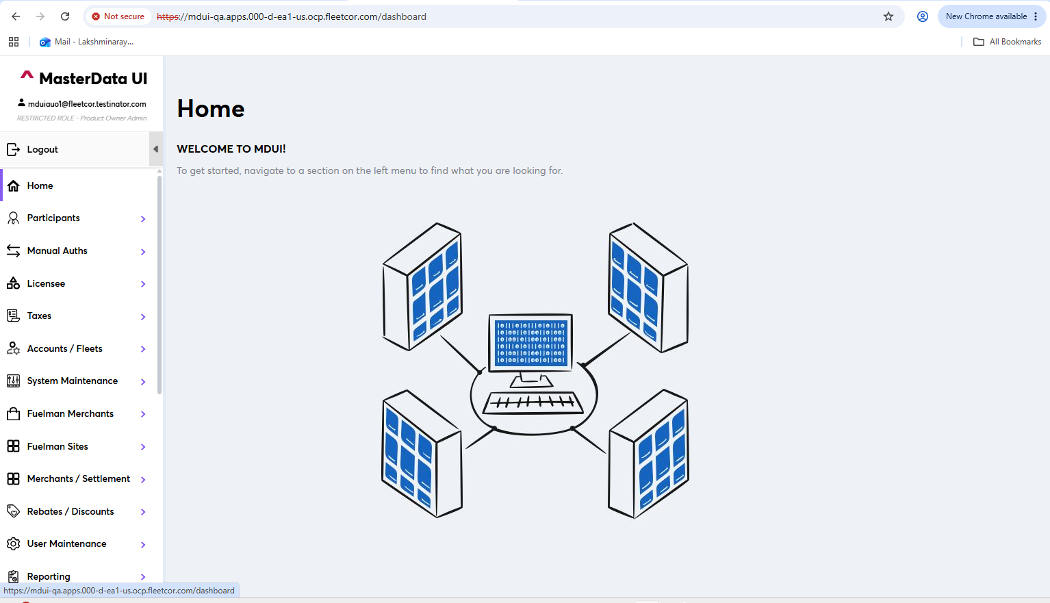
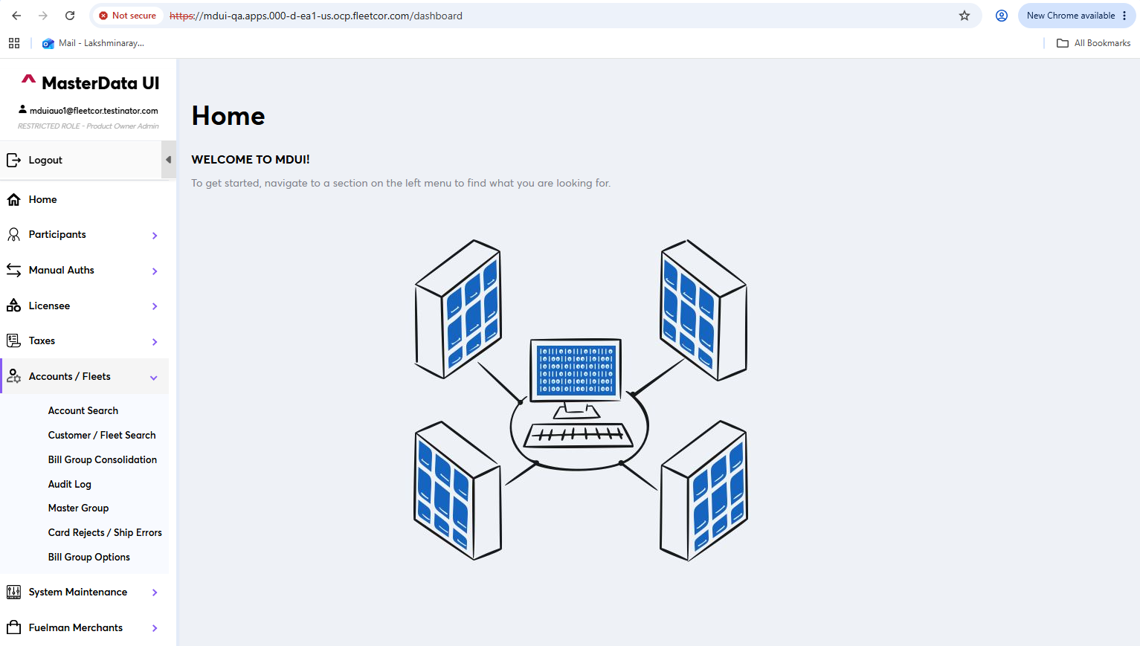

2. Customer/Fleet Search

Step-by-Step Procedure
- Navigate to Customer/Fleet Search.
- Click on createt button and Select the FleetNet customer option.
- Verify that the FleetNet customer creation/search flow is displayed.

Expected Result
The FleetNet customer flow is selected successfully.
Screenshot 3
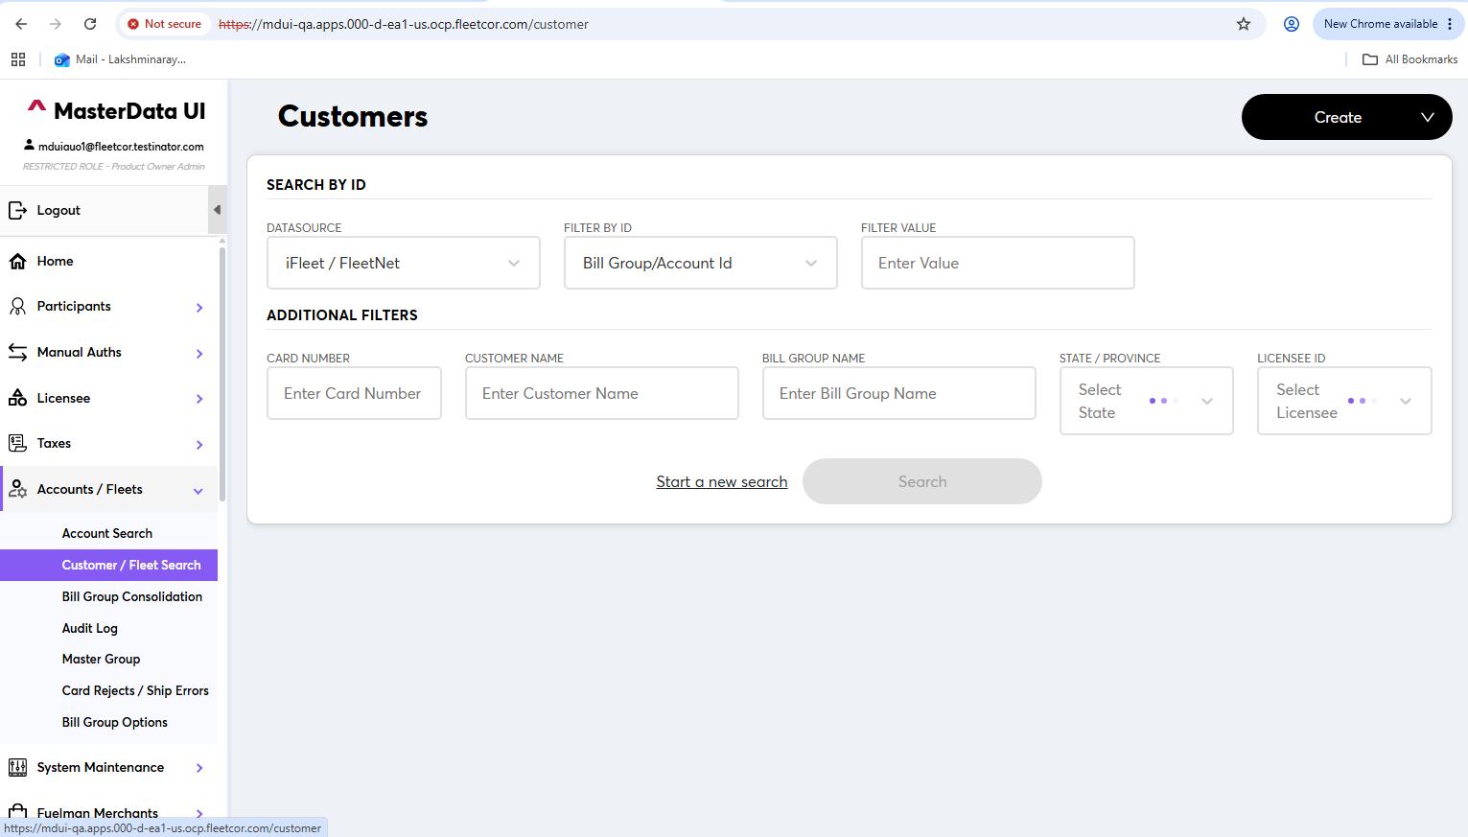
Screenshot 4
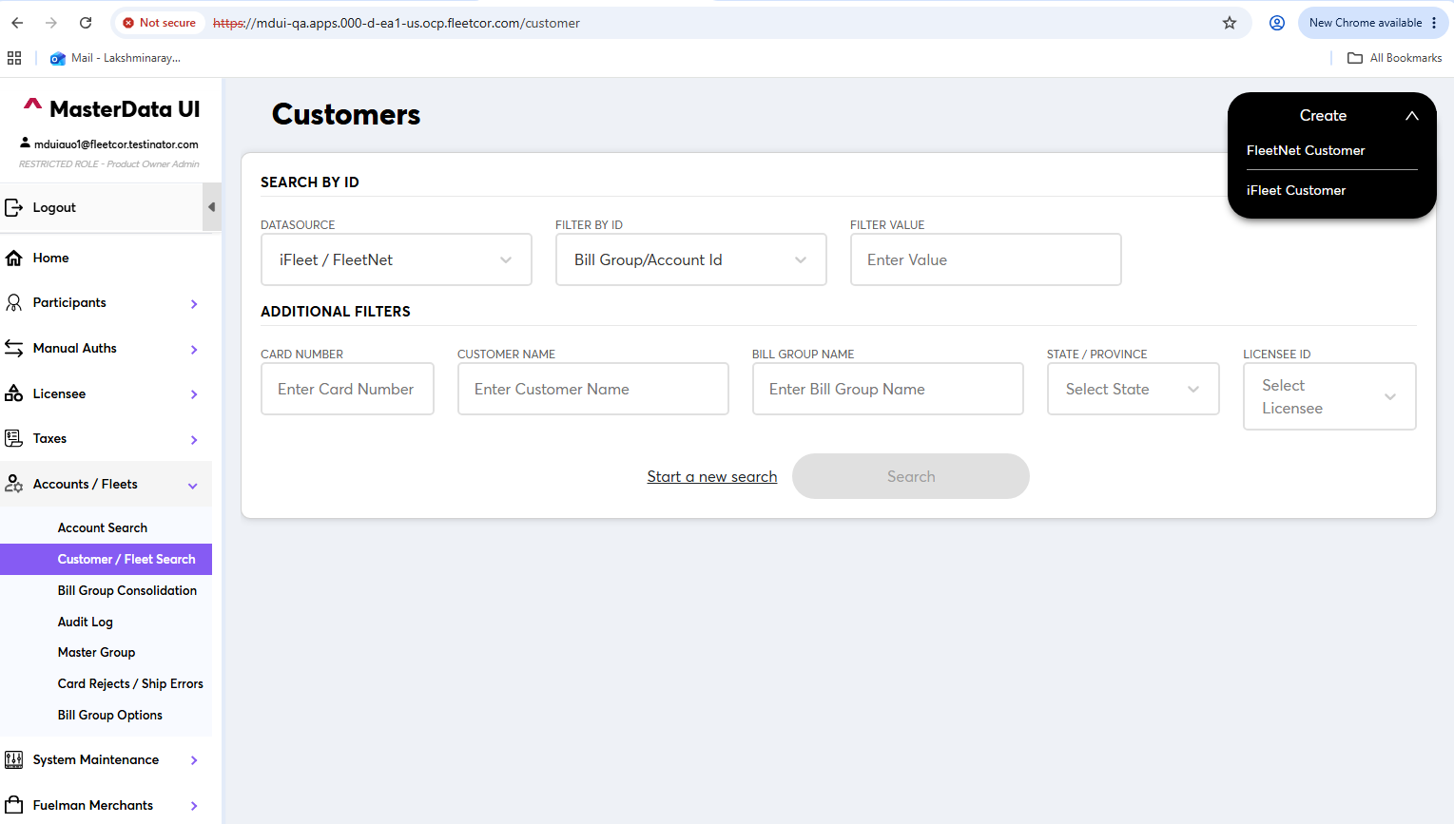

3. Enter Customer Details
Create the customer and enter the data in all mandatory fields.

Step-by-Step Procedure
- Start the customer creation process.
- Enter the required information in all mandatory fields.
- Review the entered information to make sure all required details have been provided.
- Proceed to the next section after the mandatory information is complete.

Expected Result
All required customer details are entered successfully.
Screenshot 5
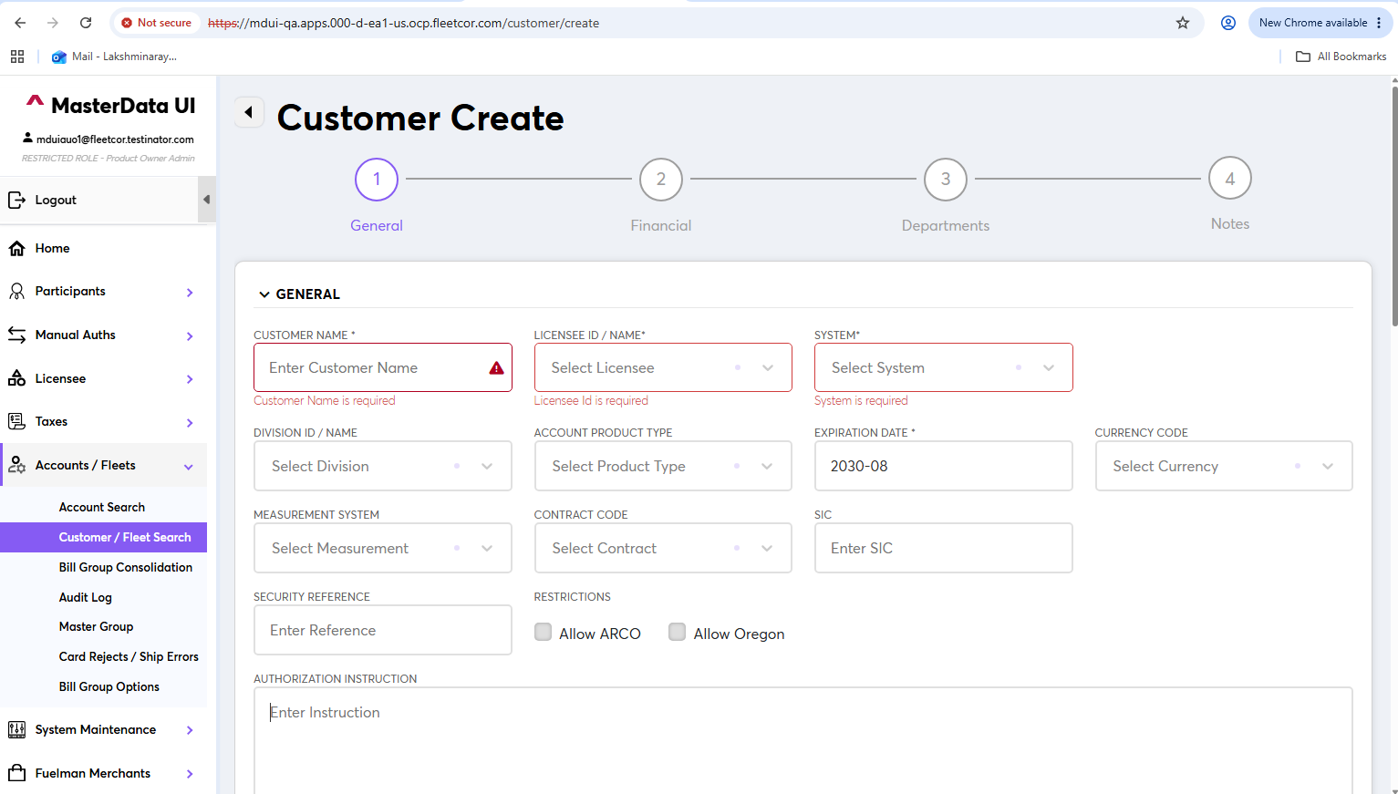
Screenshot 6
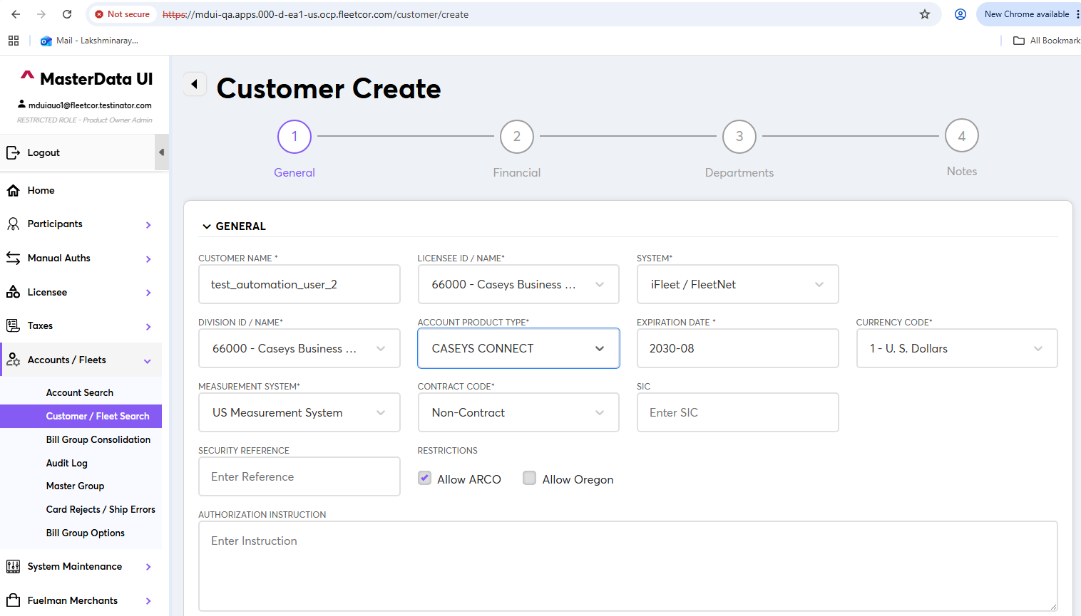

4. Address Details
Next is to fill the details in the Address section. Enter all required details in the required fields and then click Add New.

Step-by-Step Procedure
- Navigate to the Address section.
- Enter the required address information in the mandatory fields.
- Review the address information entered.

Expected Result
The address information is added successfully and the user can continue with the next configuration.
Screenshot 7
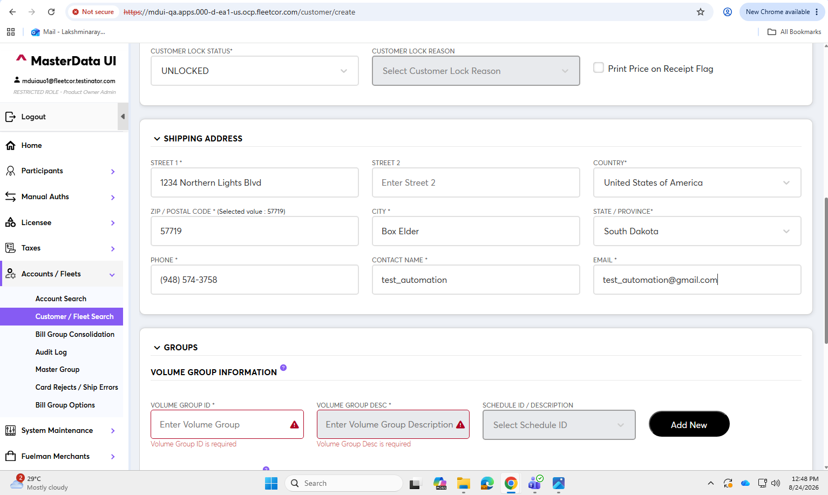
Screenshot 8
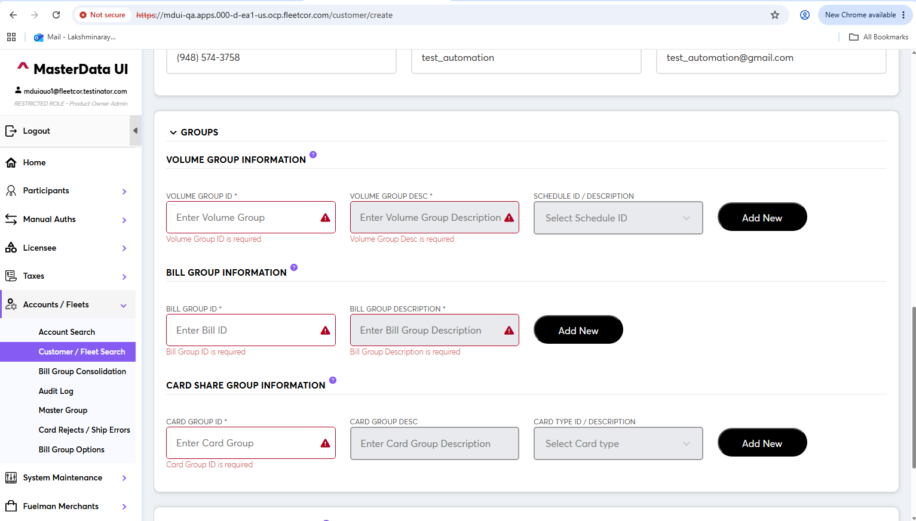
Note: Continue only after verifying that the information entered in the current section has been saved successfully.

5. Schedule ID Creation
Click Add New and then generate the Schedule ID. Repeat the same process for the next schedule entry as required.

Step-by-Step Procedure
- Click Add New for the volume group schedule entry.
- Generate the Schedule ID.
- Verify that the generated Schedule ID is displayed.

Expected Result
The required IDs are generated.
Screenshot 9
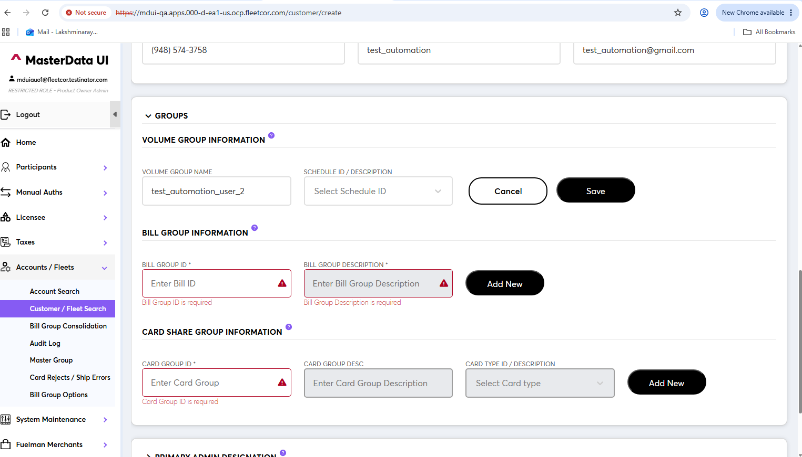
Screenshot 10
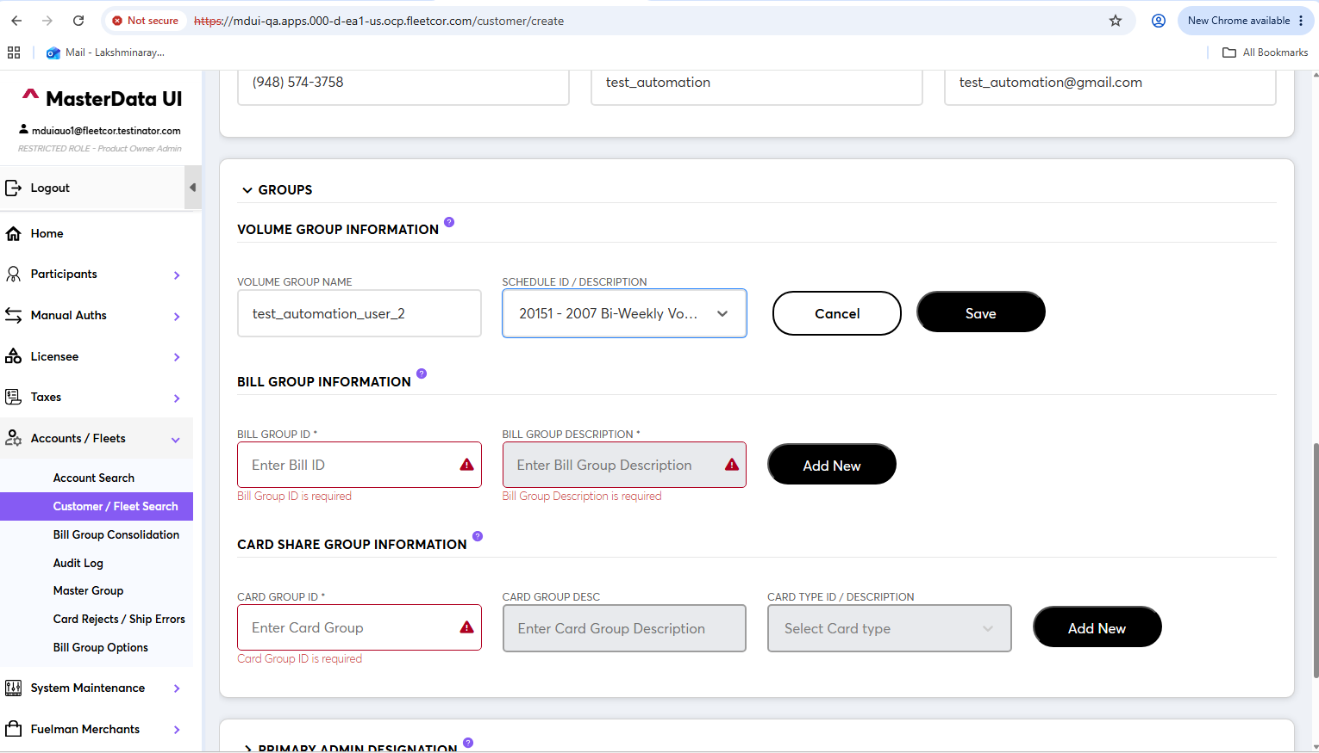

6. Save Schedule Information
The Schedule information is created after saving.

Step-by-Step Procedure
- Save the entered schedule information.
- Verify that the schedule entry is retained after saving.
- Confirm that the generated Schedule ID remains associated with the saved entry.

Expected Result
The schedule information is successfully created and saved.
Screenshot 11
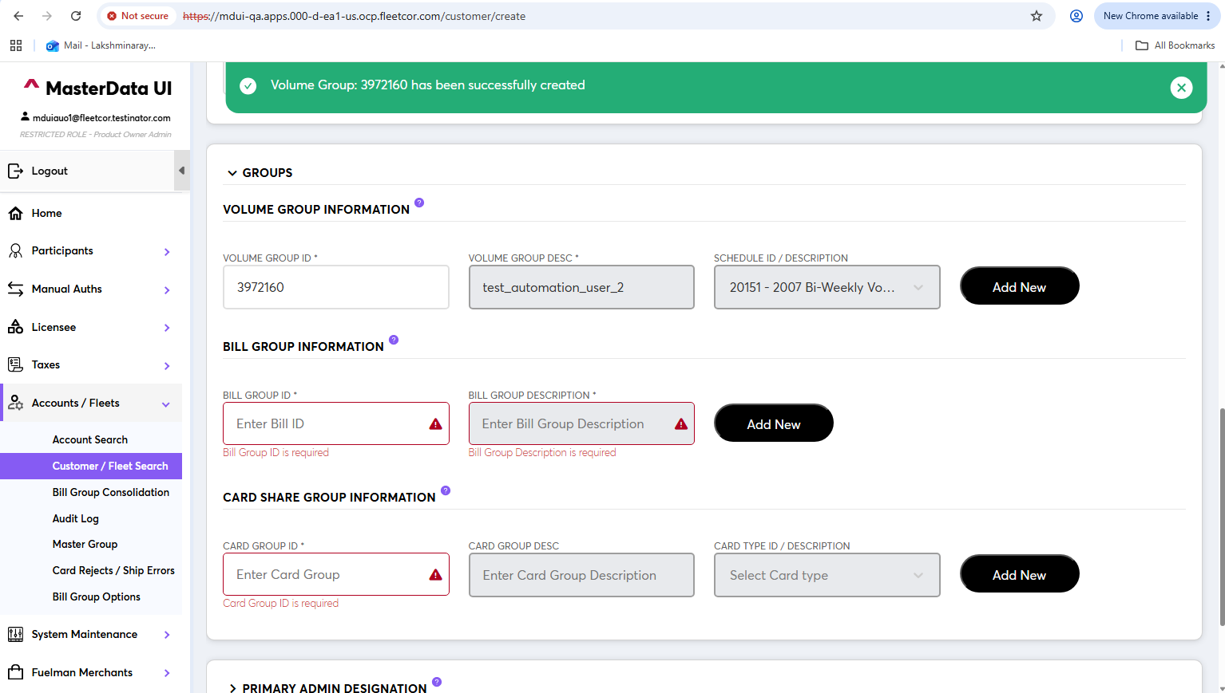
Screenshot 12
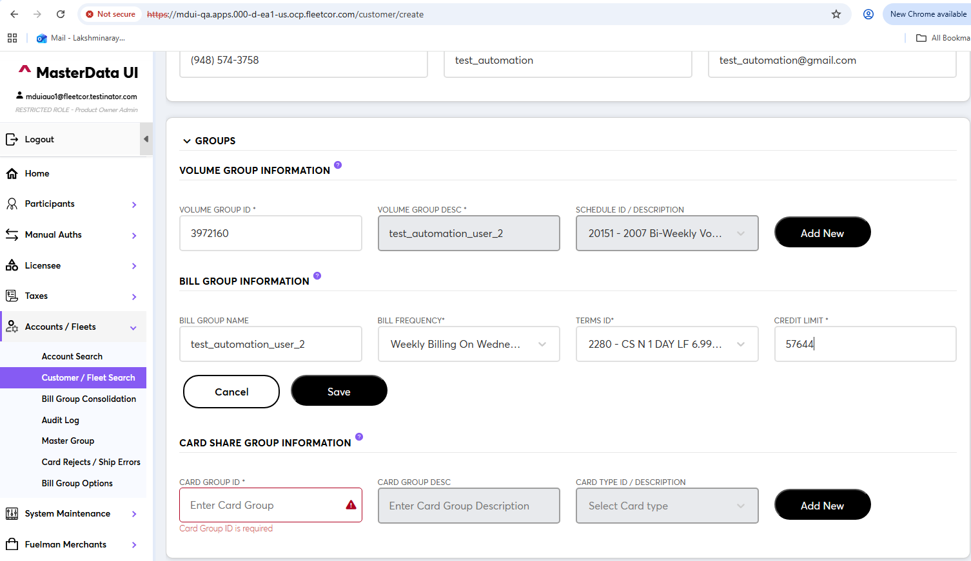

7. Complete the Required Schedule Fields
The same process is followed for all three fields/entries shown in the flow.

Step-by-Step Procedure
- Complete the required information for each of the three applicable fields/entries.
- Use the same Add New/save process wherever applicable.
- Verify each entry after it is created.

Expected Result
All three applicable entries are populated/created successfully.
Screenshot 13
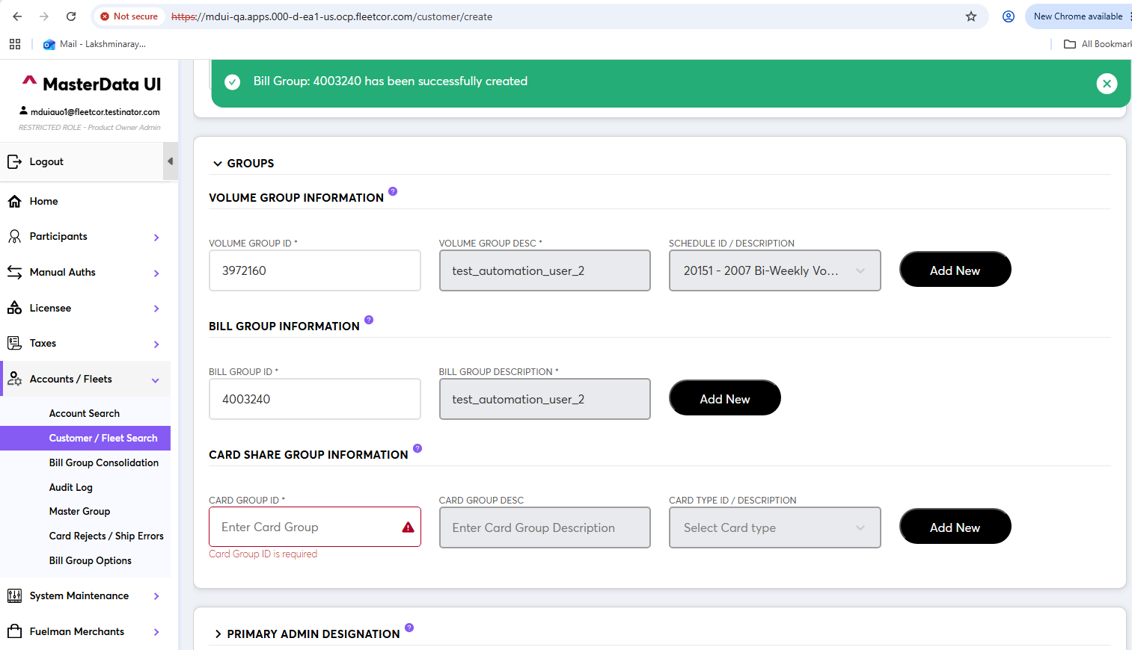
Screenshot 14
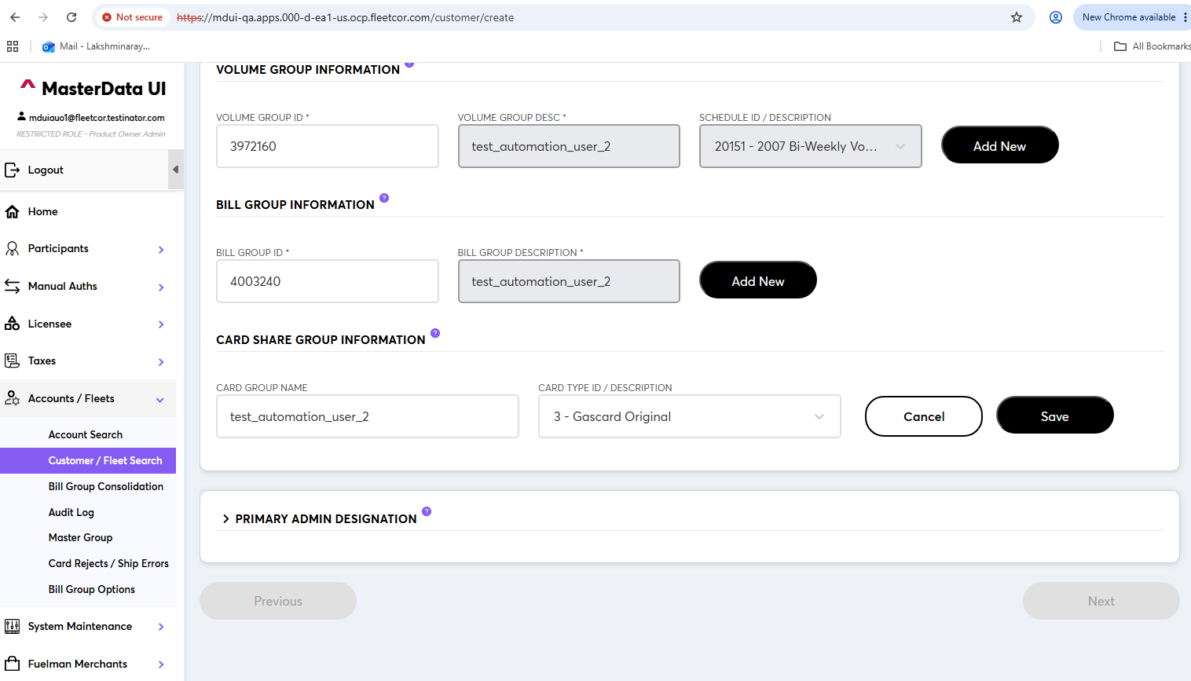

8. Financial Details
The customer has been created properly and the next step is to fill the Financial Details.

Step-by-Step Procedure
- Navigate to the Financial Details section.
- Enter the required financial information.
- Review the entered information before moving to the lower portion of the section.

Expected Result
The required financial information is entered.
Screenshot 15
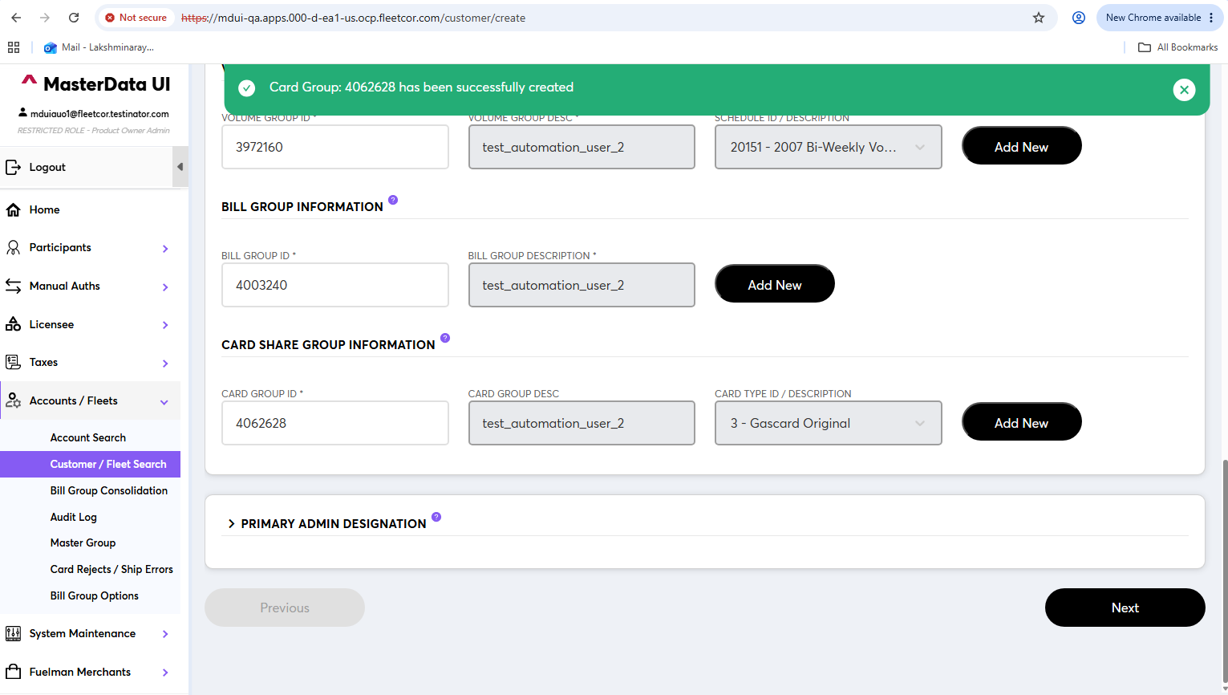
Screenshot 16
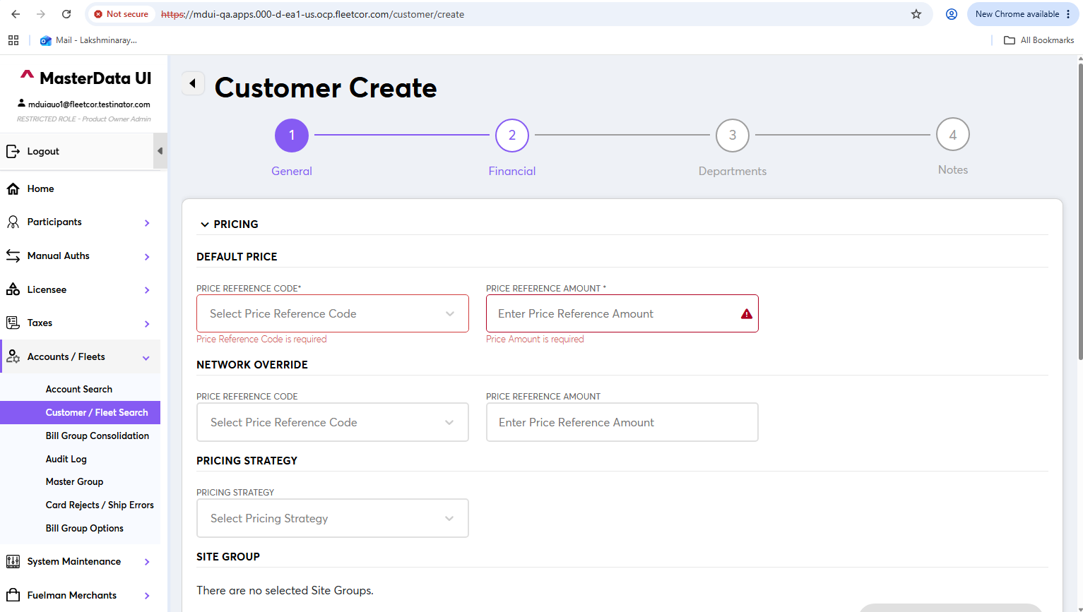
Note: Continue only after verifying that the information entered in the current section has been saved successfully.

9. Complete Financial Details
Fill all the required details and continue down the page to complete the remaining required information.

Step-by-Step Procedure
- Complete all mandatory financial fields visible on the page.
- Scroll down to the lower portion of the Financial Details section.
- Enter the remaining required information.
- Verify that all required financial details have been completed.
- Click on save .

Expected Result
The Financial Details section is completed with the required information and customer is created
Screenshot 17
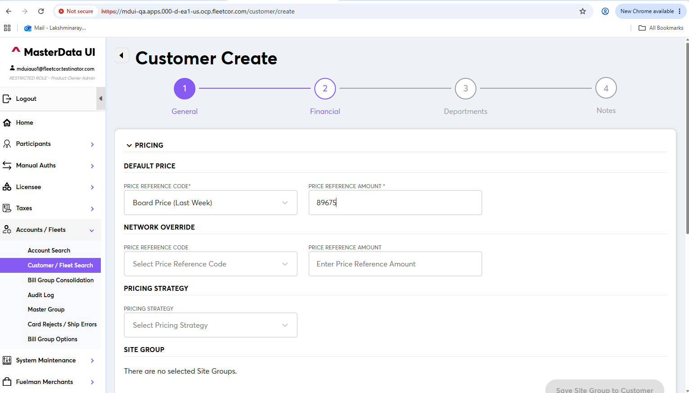
Screenshot 18
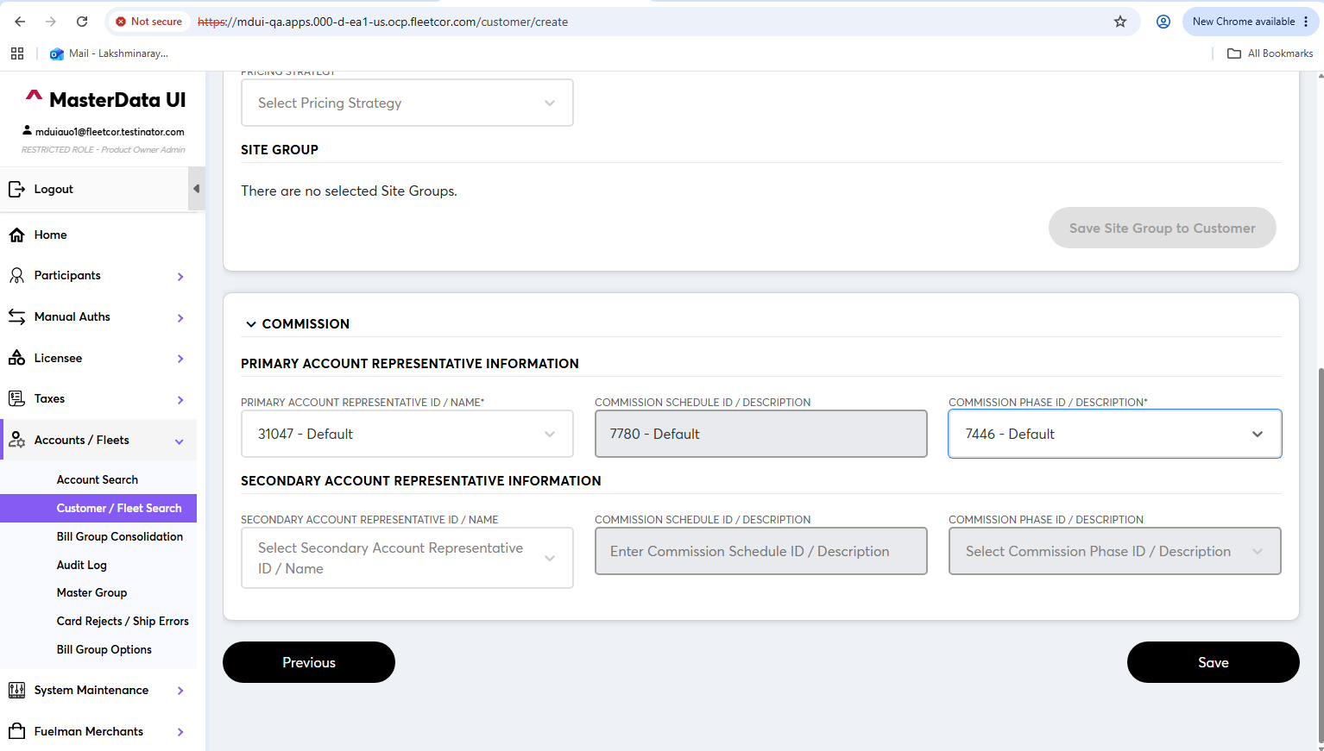

10. Department Creation
This is the third step regarding the creation of departments. Click Access IFleet to maintain departments.

Step-by-Step Procedure
- Navigate to the department creation/maintenance area.
- Select Access IFleet to maintain departments.
- Create/maintain the required department information.
- Verify that the department information is accepted.

Expected Result
The department information is maintained successfully and the user/customer is properly created.
Screenshot 19
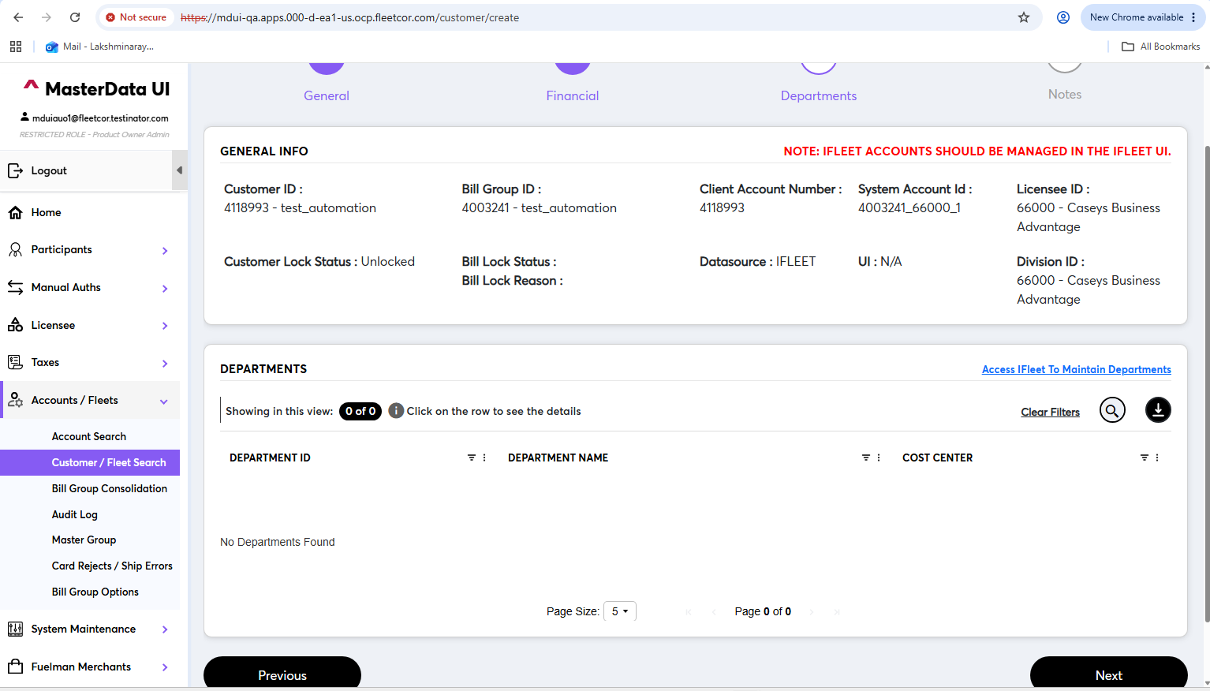
Screenshot 20
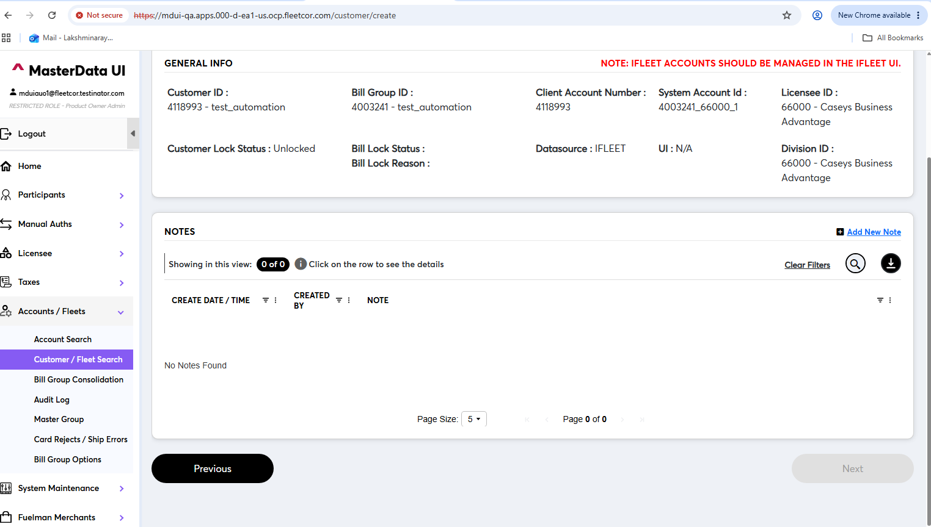
Note: Continue only after verifying that the information entered in the current section has been saved successfully.

11. Search for the Created Customer
Return to the main navigation panel on the left and click Customer/Fleet Search. Select Filter By ID and use the Customer ID generated in the previous steps.

Step-by-Step Procedure
- Return to the main navigation panel.
- Select Customer/Fleet Search.
- Set Filter By to Customer_ID.
- Use the Customer ID generated during the customer creation process.

Expected Result
Customer/Fleet Search is configured to search for the newly created customer.
Screenshot 21
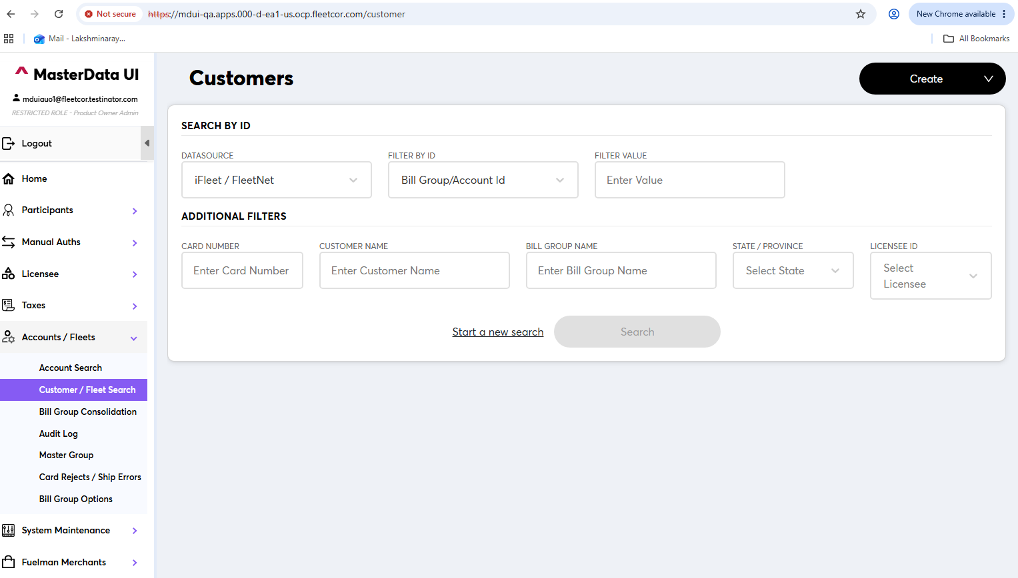
Screenshot 22
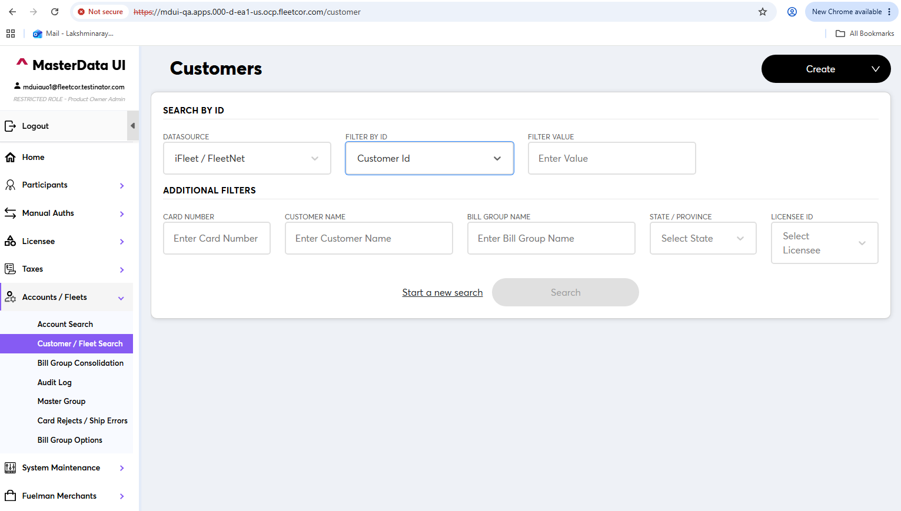

12. Verify Customer Data
Enter the Customer ID obtained earlier and click Search. The system should display the data for the customer created in the previous steps.

Step-by-Step Procedure
- Enter the generated Customer ID in the search field.
- Click Search.
- Review the returned customer information.
- Verify that the displayed data corresponds to the customer created earlier in the flow.

Expected Result
The customer record and its associated information are returned successfully.
Screenshot 23
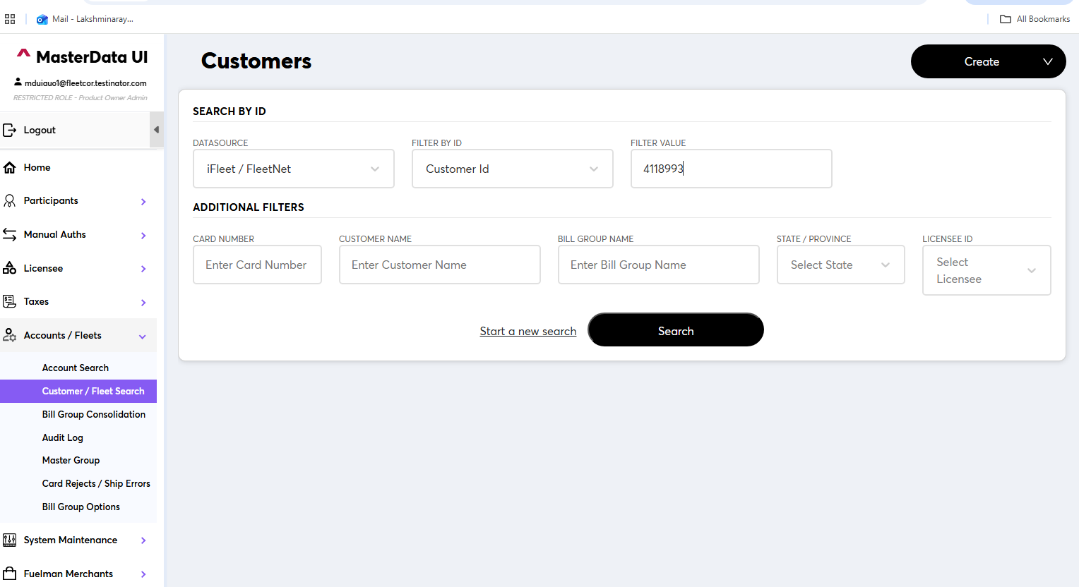
Screenshot 24
